**﻿Abstract:**

*Purpose:* This study focuses on a specific method of meat production that involves carcass purchase and meat production by packing facilities with a novel two-stage model that simultaneously considers location- routing and inventory-production operating decisions. The considered problem aims to reduce variable and fixed transportation and production costs, inventory holding cost and the cost of opening cold storage facilities.

*Design/methodology/approach:* The proposed model encompasses a two-stage model consisting of a single-echelon and a three-echelon many-to-many network with deterministic demand. The proposed model is a mixed-integer linear programming (MILP) model which was tested with the general algebraic modelling system (GAMS) software for a real-world case study in Iran. A sensitivity analysis was performed to examine the effect of retailers’ holding capacity and supply capacity at carcass suppliers.

*Findings:* In this research, the number of products transferred at each level, the number of products held, the quantity of red meat produced, the required cold storage facilities and the required vehicles were optimally specified. The outcomes indicated a two percent (2%) decrease in cost per kg of red meat. Eventually, the outcomes of the first and second sensitivity analysis indicated that reduced retailers’ holding capacity and supply capacity at carcass suppliers leads to higher total costs.

*Originality/value:* This research proposes a novel multi-period location-inventory-routing problem for the red meat supply chain in an emerging economy with a heterogeneous vehicle fleet and logistics decisions. The proposed model is presented in two stages and four-echelon including carcass suppliers, packing facilities, cold storage facilities and retailers.

**1. Introduction**

Agricultural and livestock products are the most important sources of protein, and inadequate consumption of these products is likely to cause serious health problems. One of the reasons for inadequate protein intake is the high cost of these products, which could limit people’s access. Red meat is a key source of animal protein. Based on the World Statistics Portal for Market Data, red meat consumption in Iran as an emerging economy is 20–40 kg per person. Further, it has been discussed that this source of protein consumption is decreasing due to the increasing rate of retailers’ prices for final consumers. Figure 1 illustrates trends in red meat production and consumption in Iran. As shown, red meat consumption has decreased, while red meat production has increased over time. In Iran, the rising prices of raw materials and economic sanctions have led to a dramatic increase in the price of red meat, a 2–3 fold increase in the price per kg of red meat in 2019 compared to 2016. As a result, the consumption rate of red meat (as the most important source of protein in Iran) has decreased significantly. In this regard, this research sets to design and optimise the red meat supply chain to reduce costs as a strategy to reduce the final price of the product.

In a theoretical context, the supply chain of any product consists of three parts, i.e. upstream, midstream and downstream. Improving the performance of each of these parts improves the performance of the entire chain, consequently reducing the total costs and final product prices. Upstream operations involve the procurement of raw materials for the product of interest. Midstream and downstream operations involve the production and distribution of the product. Supply chain management (SCM) aims to coordinate all parts of the supply chain to improve processes, minimise costs and increase productivity. To keep the price of red meat to a minimum, its supply chain must be examined and optimised. Figure 2 illustrates the studied red meat supply chain in Iran. In addition to the elements shown in this figure, the supply chain may include several opened cold storage facilities (distribution centres) for a more efficient red meat distribution system. Buying livestock and slaughtering them is not economical for some companies; thus, these companies buy carcasses, pack them and ultimately sell them to the final consumer. Moreover, the purpose of this study is to design a red meat supply chain in two stages, four-echelon, and multi-period models, in which the operational decisions of location, production, inventory and routing are considered simultaneous, and products are transported using a fleet of heterogeneous vehicles. Furthermore, the red meat supply chain starts from the carcass supply level and after performing the relevant operations, the packed meat is transferred to the retailers at the last level. To the best of our knowledge, this combination and problem have not been investigated previously based on the available literature.

There are various parameters in SCM; for instance, single-period or multi-period, single- product or multi-product, homogeneous or heterogeneous vehicle fleet, and single or multi- echelon supply chain network can all be taken into account. Furthermore, for each echelon, networks can be shaped as one-to-one, one-to-many, many-to-one, or many- to-many. Different characteristics can also be added to the model, including time window, risk management, transshipment and perishability. Furthermore, issues such as the location of facilities, routing of vehicles and inventory can be examined for each supply chain. According to the mentioned points, the type of product has a great impact on the design and analysis of the supply chain network. Over time, researchers have turned to supply chain design for a particular product, while in the past a supply chain was designed for a specific product category. Rice is an example of a product whose supply chain network has been studied. Recent articles have shown that all echelons of the supply chain should be considered for better decision-making; nonetheless, as the number of echelons of the chain increases, it makes the model more complex. As a result, modelling approaches have moved towards staging based on product type, vehicle type, or different strategic decisions. Due to differences in some characteristics of the agricultural supply chain, such as the type of product transported during the supply chain or the type of vehicles used to transport products, it is necessary to model the problem in several stages to achieve appropriate results. Since the product transported in the red meat supply chain consists of two different types, a two-stage model has been scheduled. In the first stage, the carcass is prepared and distributed among the packing facilities, and then the red meat production operation is performed. In the second stage, the packed meat will be distributed among retailers, which cold storage facilities will be also used if needed.

In the present research, the supply chain spans from carcass purchase to the delivery of packed meat to retailers. The proposed model is a multi-period, single-product model for the red meat supply chain with a heterogeneous vehicle fleet. Moreover, the designed network consists of four echelons, including carcass suppliers, packing facilities, cold storage facilities and retailers. The proposed model is presented in two stages; the first stage includes carcass suppliers and packing facilities, and the second stage includes packing facilities, cold storage facilities and retailers. After solving the model in both stages, the number of products transferred at each level, the number of products held in storage nodes, the quantity of red meat produced, the cold storage facilities that are opened, and the required vehicles are specified. Additionally, a sensitivity analysis is performed on the holding capacity of retailers and supply capacity at carcass suppliers, and changes in the solutions are examined. The originality of this paper can be summarised as follows:

* Designing a two-stage, four-echelon red meat supply chain from carcass suppliers to retailers by simultaneously considering location-routing and inventory-production operating decisions;
* Providing two mixed-integer linear programming (MILP) models for red meat supply chain (a single-echelon and a three-echelon problem for the first and second stage respectively) in which a heterogeneous vehicle fleet is considered;
* Solving a real instance using information from a meat supplier in Iran and comparing the outcomes of solving the model with real information;
* Analysing the effect of retailers’ holding capacity and supply capacity at carcass suppliers on the outcomes obtained from solving the proposed model with different scenarios.

The remainder of this paper is structured as follows. Section 2 provides a review of the literature on the design of various supply chain networks, including food supply chains. The proposed models for the red meat supply chain network are presented in Section 3. In Section 4, these models are applied to a real case scenario in Iran. In Section 5, sensitivity analysis and discussion are conducted. Finally, Section 6 provides the conclusion and future research directions derived from the research.

**2. Literature review**

Recently, network design for agricultural and livestock products has received increasing attention from researchers. This has led to an increase in the efficiency of these supply chains and a reduction in the cost of these products. This section provides a review of the literature. Studies on network design for agricultural and livestock products can be divided into qualitative and quantitative categories. Qualitative studies have mainly focused on issues such as improving supply chain quality, product tracking methods and systems, factors influencing the price of products, lead time (due to perishability of the products), etc.. On the other hand, quantitative studies have focused on the design of the supply chain network for the product of interest and the variables related to SCM, including reducing supply chain costs, increasing supply chain profits, reducing lead time and reducing product shortages. In the following sub-sections, relevant studies are categorised and reviewed in detail.

*2.1 Supply chain network design and management*

Although SCM has received considerable attention since the early 1980s, it is not particularly well understood and there is still the opportunity for improvements and future research. THEY were amongst the first investigators in the study of supply chain design. They employed Benders’ decomposition approach to determine the optimal number and location of distribution centres (DCS) to be established. THEY proposed a multi-product MIP model for a three-echelon, capacitated plant and a warehouse location problem that aimed to minimise operating warehouses and the annual fixed costs of establishing as well as total transportation and distribution costs. Lagrangian relaxation was applied to the model as an effective approach for solving large-scale problems. THEY developed a simultaneous model that incorporates economic order quantity and safety stock decisions into a facility location problem with three echelons, including a plant, warehouses and retailers. This was a real case of frozen food distribution, and they solved the problem through Lagrangian relaxation. THEYdeveloped a mathematical programming model based on Lagrangian relaxation to determine optimal ordering size, client assignment and warehouse locations for a location-distribution-inventory problem. Demand was stochastic and normally distributed. Furthermore, the objective function minimised transportation costs, ordering and inventory costs, safety stock costs and fixed and variable warehouse costs. THEY proposed a mixed-integer programming model for a location-allocation-inventory problem. In their proposed model, customers can be served directly by a warehouse or a plant. Moreover, there was a constraint on the production capacity of plants; however, no capacity constraint was considered for warehouses. THEY studied the network design for a supply chain consisting of plants, DCs and customers. The model incorporates decisions about the optimal number and location of plants and DCs as well as the quantity of product flow between facilities. They considered both direct and indirect shipments to customers. The objective was to minimise opening costs, transportation costs and costs associated with unused products in plants and DCs. THEY developed a two-stage mixed-integer programming model for a location-routing problem. As a novel approach, they considered cross-docking centre location and vehicle routing scheduling simultaneously. Their proposed algorithm was based on hybrid simulated annealing and tabu search. SCM and related decisions have been investigated to reduce costs by various researchers. However, some articles have focused on CO2 emissions to model their problems. THEY developed a mathematical model for an inventory-routing problem that considers lost sales for perishable goods. They used an algorithm based on simulated annealing and tabu search to solve the problem on a large scale. The objective function minimised the total cost of transportation, lost sales and holding inventories. In the related articles on SCM, the scholars considered the location-inventory-routing problems, and most of them concentrated on the design of supply chain networks and algorithms.

More recent studies on supply chain network design have been investigated. For instance, THEY developed a bi-objective location-inventory-routing problem for hazardous material management. This study incorporates risk into the model, and the objective function minimises total cost and risk. THEY studied a location- inventory-routing problem for perishable products. They considered a homogeneous fleet of vehicles and used a genetic algorithm to solve the model on a large scale. The problem was formulated as a many-to-many network, and the objective function considered warehouse fixed location cost, routing cost and inventory holding cost. THEY addressed a multi-objective location-inventory-routing problem for a three-echelon supply chain of perishable products. Demand was stochastic, and the model was a multi-period, multi- product and heterogeneous fleet composition with an integer nonlinear programming structure that was solved by Lagrangian relaxation. THEY developed a multi- period, multi-product and green inventory-routing problem that sought to minimise both costs and CO2 emissions. A key innovation in their research was to consider transshipment costs. Their proposed model was a mixed-integer linear program solved on a small scale. Supply chain network design and location-inventory-routing problems have been considered to reduce costs by several researchers. In this regard, some articles focused on an exact method to solve their problems. The application of the two-echelon vehicle routing problem in last-mile delivery with drone delivery has been also investigated recently.

*2.2 Supply chain network design for agricultural products*

In the related articles on agricultural products, scholars have investigated supply chain network design, with most of them concentrating on the nature of agricultural products. THEY studied a two-echelon LRP for a perishable food supply chain with time windows. Their proposed model was multi-period and considered a heterogeneous vehicle fleet. Finally, a metaheuristic algorithm was employed to solve the model. THEY solved a multi-product distribution problem with cross-docking. A time window constraint was considered for each delivery and pickup. Their objective function minimised inventory holding costs and transportation costs. THEY proposed an optimisation model for apple harvest planning. Their objective function sought to minimise costs related to workforce, goods and fruit loss due to poor quality. THEY used the multi-criteria decision-making (MCDM) approach to design a supply chain of protein foods. The results of solving the model indicated that their design resulted in optimal values for different variables. THEY proposed a multi-objective vehicle routing problem with time windows for a food supply chain. The first objective function minimised fixed costs, transportation costs, penalty costs and damaged costs. The second objective function of their proposed model maximised the average freshness of products. Finally, the model was solved using a two-stage heuristic algorithm based on the Pareto variable neighbourhood search and genetic algorithm. Agricultural products and supply chain network design have been considered to reduce costs by various researchers. In this regard, some articles have focused on a particular agricultural product to model their problems. The application of supply chain network design models in distributing wheat considering sustainability indicators has also been recently investigated. The sustainable network design of the supply chains due to the importance of economic, social and environmental pillars in agricultural products has been recently considered via multi-objective optimisation models.

*2.3 Red meat supply chain network design*

To develop the holding and logistic condition of the red meat supply chain and minimise costs, the well-designed integrated network for supply chain components is amongst the most important researches. THEY designed a supply chain network for red meat with probabilistic conditions. Their proposed model was formulated in two stages. The first stage involved strategic location decisions while the second stage involved operating decisions. The model was solved through a real case in Norway. THEY designed and solved a beef supply chain with environmental considerations. Their proposed model was a multi-objective linear programming model aimed to minimise inventory and transportation costs while minimising CO2 emissions from transportation operations. Mohammed and Wang used a multi-objective probabilistic programming approach to design a meat supply chain network. Their objective functions minimised total transportation cost, the number of vehicles and delivery time. Mohammed and Wang developed a fuzzy multi-objective model for a green meat supply chain. Their proposed model aimed to minimise the environmental impact of the supply chain and was solved using MCDM. THEY developed a multi-product production-routing problem with delivery time windows and heterogeneous vehicles. Their objective function minimised routing cost as well as inventory holding cost for the supplier and retailers. Their model was tested on a European meat store chain. Sustainable and resilient supply networks in the meat industry in Iran have been recently designed and optimised via a multi-objective model. Beyond these mentioned developments, the main studies are presented in Table 1.

According to the studies conducted in the field of the agricultural supply chain, especially the red meat supply chain, it is possible to identify gaps in this field. For instance, from a supply chain design and management perspective, THEY proposed a multi-period, multi-product inventory-routing problem with a heterogeneous vehicle fleet, by considering the likelihood of vehicle failure via a metaheuristic algorithm. Moreover, THEY proposed a model for a two-echelon vehicle routing problem by considering time uncertainty thru a two-stage GRASP with path relinking. However, in this research, in addition to investigating vehicle routing and inventory problems, operational decisions in production, inventory and location are also addressed. Furthermore, from a supply chain design and agricultural perspective, THEY proposed a location-inventory-routing problem for a three-echelon food supply chain consisting of a single supplier, multiple depots and multiple retailers. They considered a probabilistic and normally distributed retailer demand to minimise fixed warehouse installation costs, transportation costs and inventory holding costs via a mixed-integer nonlinear program and was solved using a heuristic algorithm. In their study, the single- period time horizon was considered; however, in this research, the multi-period time horizon is considered. Moreover, THEY designed and solved a bi- stage model for a rice supply chain consisting of producers, DCs, rice factories and customers. The objective functions for both levels sought to minimise the supply chain costs, including fixed DC, production, inventory holding and transportation costs. In their research, the operational decision related to the vehicle routing problem was not considered; however, in our proposed approach, it has been investigated as a key issue. Eventually, from the red meat supply chain perspective, THEY proposed a multi-period location-inventory-routing problem model with heterogeneous vehicles using the general algebraic modelling language (GAMS). In their research, a single-stage model containing the livestock suppliers to retailers was presented; however, in the current research, a two-stage model containing the carcass suppliers to retailers is proposed. Moreover, THEY proposed a multi-objective green supply chain for meat via a multi-period, multi-product and multi-level model for a homogeneous vehicle fleet. However, in this article, a heterogeneous vehicle fleet is considered.

By and large, the supply of raw materials of this supply chain is one of the issues that should be considered in the design of a red meat supply chain. In other words, livestock supply is not always at the first level of the red meat supply chain; hence, organisations may decide to prepare the carcass first according to various issues and then perform the meatpacking and distribution operations. As a result, this is one of the most important questions and issues that this research addresses. According to previous studies, consideration of the supply chain of agricultural products in several stages makes the problem closer to the real world, and more accurate results are obtained. Also, this will be even more important when the product shipped is different along the supply chain. In the red meat supply chain, the transported product is different in the network. In this regard, this research addresses this issue. Moreover, in the present research, supply chain design is assumed in a two-stage, four-echelon model by simultaneously considering location-routing and inventory-production operating decisions. Furthermore, the fleet of vehicles used in this study is considered heterogeneous. Compared to previous researches, this combination and problem have not been investigated. Furthermore, solving real instances using information from a meat supplier in Iran and comparing the outcomes of solving the model with real information could demonstrate the applicability of the proposed model. Finally, to achieve better results, a series of sensitivity analyses are performed on different parameters of the problem, and the reliability of the problem was tested in different scenarios.

**3. Modelling**

In this section, the problem is stated and presented, and the case red meat network is described. Moreover, the assumptions and the two-stage model are formulated in this section. The schematic algorithm of the method used is represented in Figure 3.

Figure 4 illustrates the schematic diagram of the presented model for a red meat supply chain network. As shown in this diagram, the considered supply chain consists of two stages. In the first stage with a single echelon, the carcass is transported from the supplier to the packing facilities. In the second stage with three echelons, products are transported either directly from packing facilities to retailers or from packing facilities to cold storage facilities and then to retailers.

The proposed model is a multi-period and single-product MILP model with a heterogeneous vehicle fleet. The objective of the first stage of the model is to determine the quantity of packed meat produced and held in each period, the amount of carcass transported to packing facilities, and the best vehicles and routes for transportation. The objective of the second stage is to determine the quantity of packed meat transported in each route, the amount of meat held at each node, whether cold storage facilities are opened in the supply chain, and the best vehicles and routes for transportation. Notations used in this research are described as follows.

3.4 Model stage 1

There are multiple carcass suppliers and multiple packing facilities, and retailers’ demand is deterministic and variable in different periods. Carcass suppliers have a limited supply capacity in each period. Besides, meat production by packing facilities deals with two types of costs, i.e. variable cost of red meat production and fixed cost of meat production processes. Furthermore, packing facilities have limited production throughput. Note that, packing facilities can store meat, and each warehouse has a specific capacity for holding products and incurs inventory holding costs. In this model, each echelon uses a different fleet, and the number of vehicles is limited. Moreover, vehicles have different and limited capacities. Vehicles start their trip from carcass suppliers and return after delivering carcasses. Besides, variable transportation costs per trip and fixed vehicle costs are considered. The objective function (1) minimises the total supply chain costs, including the cost of carcass purchase from suppliers, variable and fixed production cost at packing facilities, inventory holding cost at packing facilities, variable transportation cost and fixed vehicle cost.

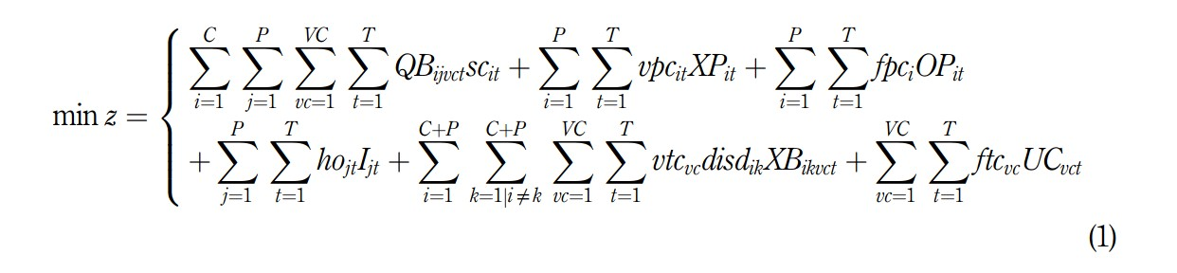

The constraints of the first stage are represented below. Constraint (2) is the inventory balance constraint for packing facilities.

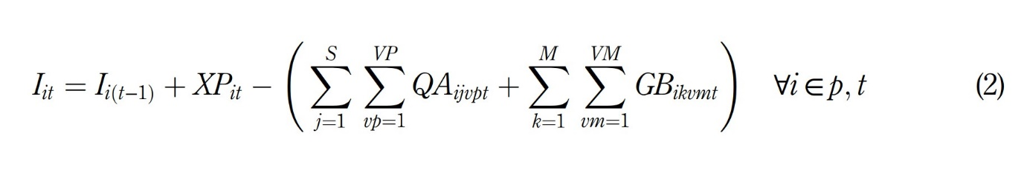

Constraint (3) sets the amount of carcass needed based on the meat conversion factor.

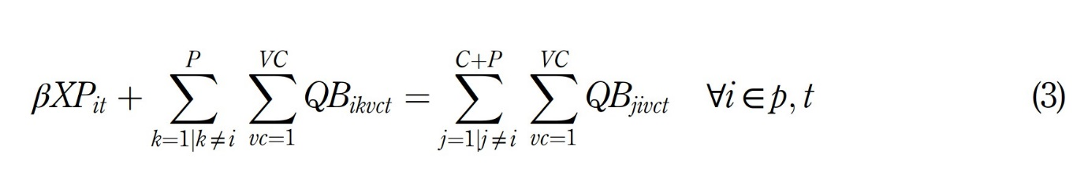

The capacity constraints are formulated in Eqs. (4) to (7). Constraint (4) ensures that meat production by packing facilities does not exceed their maximum throughput. Constraint (5) ensures that products held in the warehouses of packing facilities do not exceed the maximum allowable capacity. Constraint (6) denotes that the amount of carcass shipped by the supplier does not exceed the associated supply capacity. Constraint (7) indicates that, at each echelon, the total volume of products loaded on the vehicle does not exceed its maximum capacity.

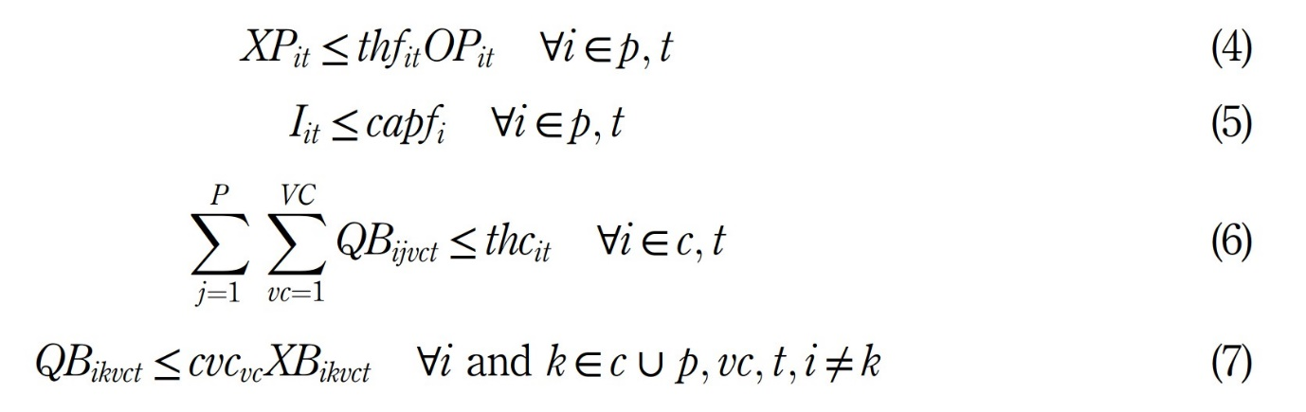

The next set of constraints are related to transportation. Constraint (8) clarifies that if a vehicle is used for transportation, it must start its trip from the source node. Constraint (9) ensures that the number of vehicles used at each echelon does not exceed availability limits. Constraint (10) is related to node assignment at each echelon, convincing that a vehicle entering a node should leave the same node. Constraint (11) precludes the formation of sub- tours among nodes.

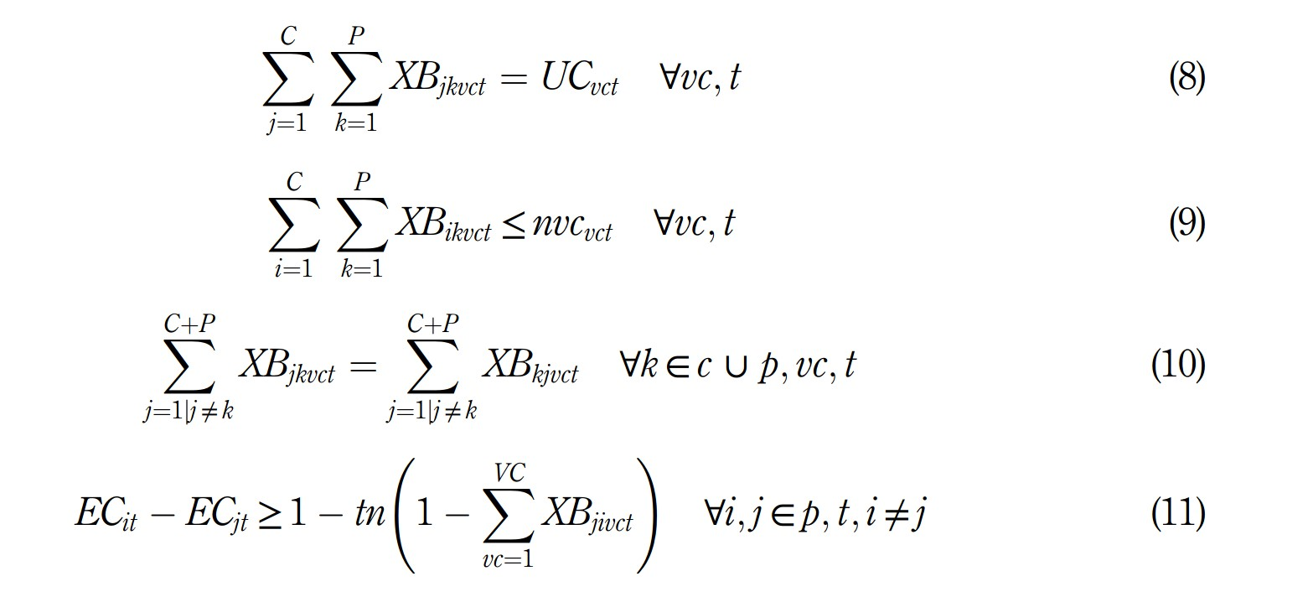

Constraint (12) certifies that the quantity of products transported by a vehicle is greater at the start of the trip than along the route.

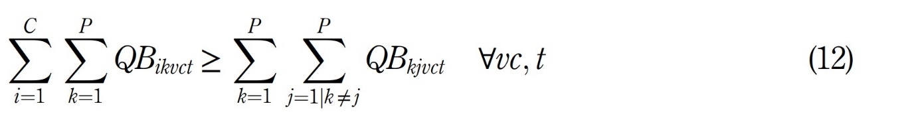

The last set of constraints is related to the decision variables. Constraint (13) is related to decision variables for the first stage of the model.

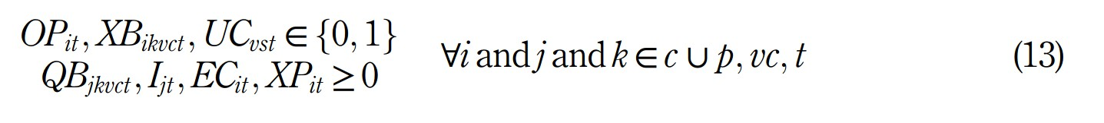

*3.5 Model stage 2*

Model stage 2 consists of multiple packing facilities, multiple cold storage facilities and multiple retailers. The demand is deterministic and alternates in different periods. Packing facilities deliver meat to retailers either directly or indirectly through cold storage facilities. Besides, cold storage facilities and retailers can store meat, and warehouses at each node have a specific capacity for holding products and incur inventory holding costs. Note that, in this model, each echelon uses a different fleet, and the number of vehicles is limited. Also, vehicles have different and limited capacities. Vehicles start their trip from packing facilities and return to the initial node after delivering products. In this routing, variable transportation costs per trip and fixed vehicle costs are considered. The second stage objective function (14) is to minimise the total supply chain costs, including inventory holding costs at nodes, cold storage facility opening cost (if needed) and variable transportation cost, as well as fixed vehicle cost at each echelon.

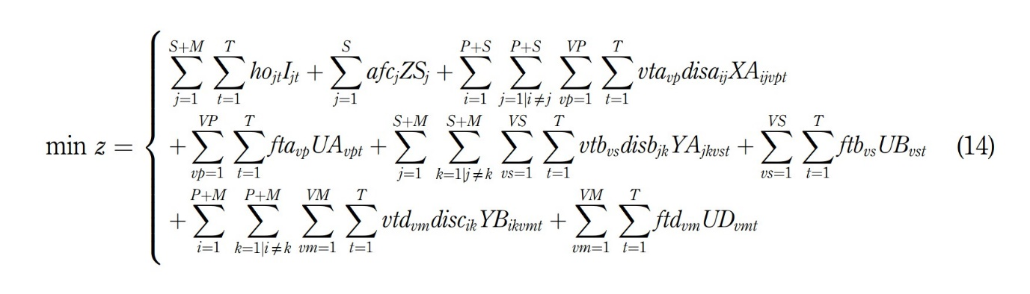

The first set of constraints in the second stage is related to inventory balance. Constraints (15) and (16) are related to inventory balance at cold storage facilities and retailers, respectively.

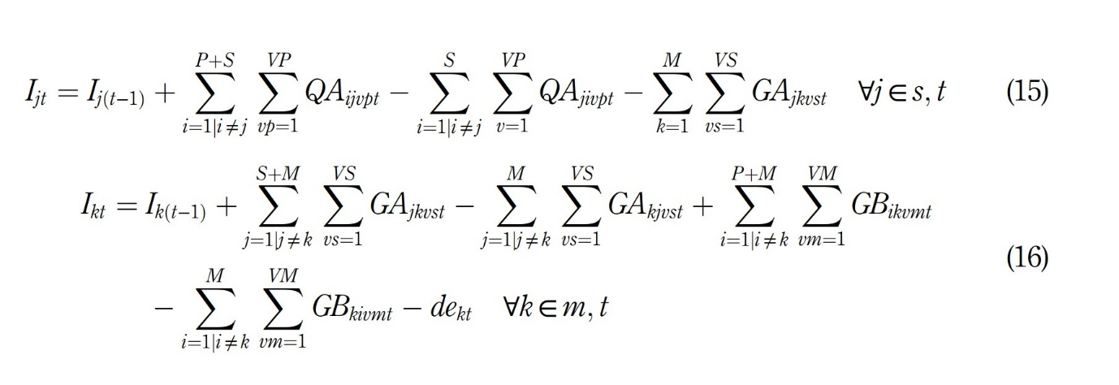

The second set of the second stage constraints are related to the capacity. Constraint (17) determines that if a cold storage facility is opened, the amount of meat in the warehouse of the cold storage facility does not exceed the maximum allowable capacity. Constraint (18) indicates that the quantity of products held in retailer warehouses does not exceed their holding capacity. Constraints (19) to (21) ensure that, at any echelon, the total volume of products loaded on a vehicle does not exceed its capacity.

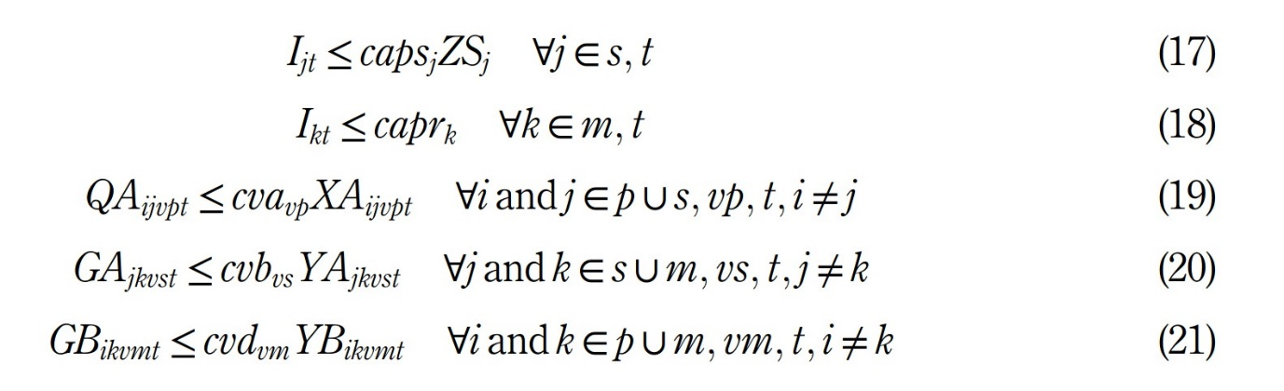

The vehicle-related constraints are added next. Constraints (22) to (24) ensure that if a vehicle is used, it should start its trip from the source node. Constraints (25) to (27) ensure that the number of vehicles used at each echelon does not exceed availability limits.

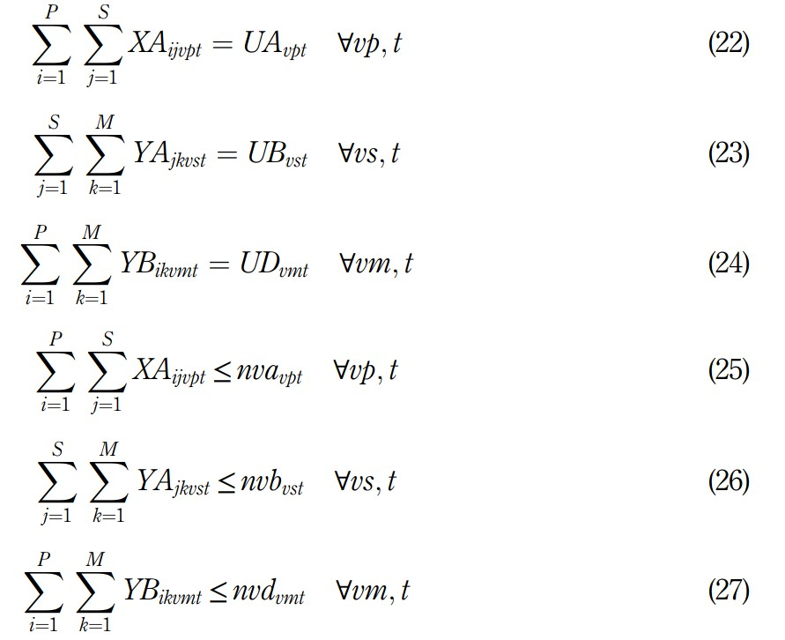

Constraints (28) to (30) are related to node assignment at each echelon, ensuring that a vehicle entering a node should leave the same node.

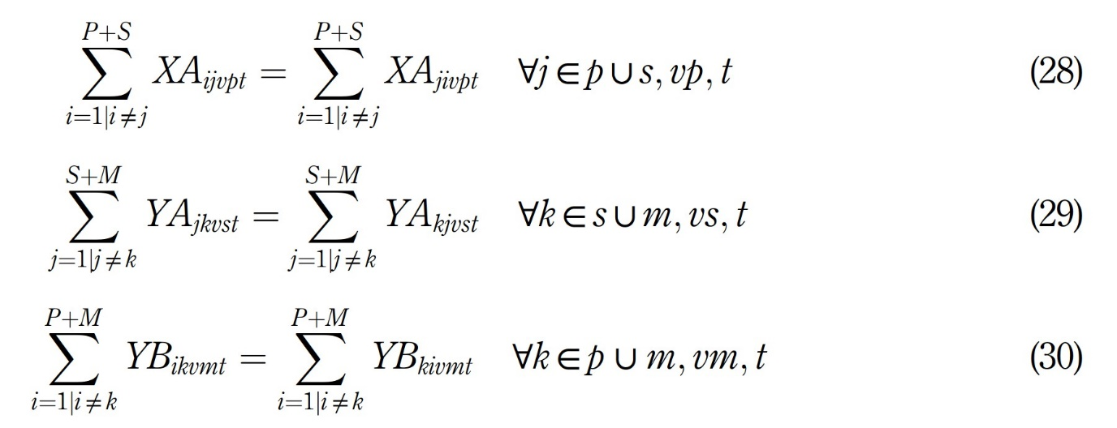

Constraints (31) to (33) preclude the formation of sub-tours among nodes.

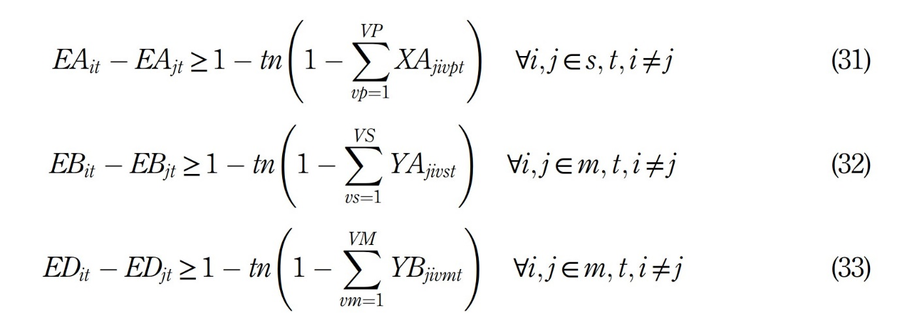

Constraints (34) to (36) ensure that the quantity of products transported by a vehicle at each echelon is greater at the start of the trip than along the route.

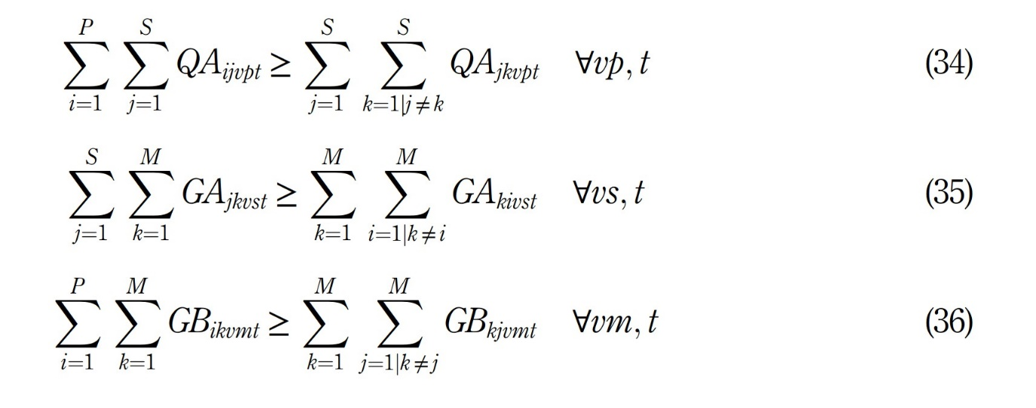

The next two constraints are due to the balance of products entered and sent from cold storage facilities. Constraint (37) ensures that the quantity of products transported from cold storage facilities does not exceed its capacity. Constraint (38) convinces that the quantity of products transported from packing facilities to cold storage facilities is equal to the quantity transported from cold storage facilities to retailers. Constraint (39) ensures that the quantity of products produced by packing facilities plus the products held in the warehouses of packing facilities is more than or equal to the number of products transported from packing facilities to cold storage facilities, plus the number of products transported from packing facilities to retailers.

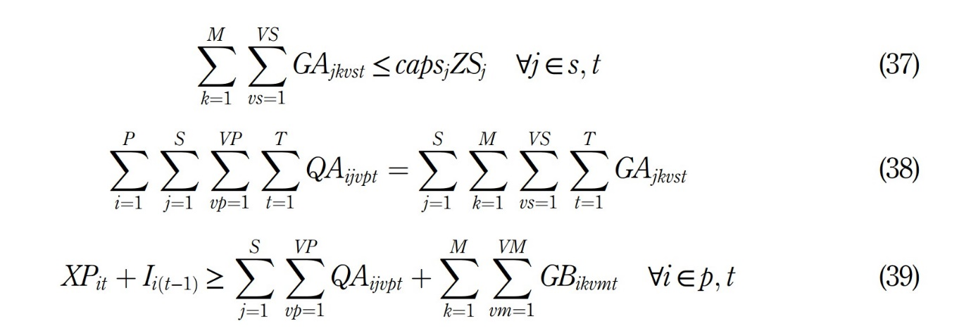

The last set of constraints, i.e. constraint (40) is related to decision variables for the second stage of the model.



﻿**4. Case study and results**

In this section, the two-stage model for the designed red meat supply chain is applied to a numerical instance. After solving the model, the outcomes are evaluated, and the best strategy for the company is determined. This instance includes 63 nodes, 42 retailers, 12 cold storage facilities, four packing facilities and five carcass suppliers. Retailers are the major stores across Iran with significant demand for red meat. The 12 cold storage facilities were randomly selected. In addition to the main meatpacking facility of the company, the rest of the packing facilities were randomly selected from different parts of the country. The five carcass suppliers were also randomly selected based on their reputation. Seven periods were considered, and the length of each period is one month. Two types of vehicles were considered at every echelon, 20-ton (v1), and 10-ton ðv2Þ vehicles. However, only for the routes among cold storage facilities and retailers (within Tehran), four types of vehicles were considered, 20-ton ðv1Þ, 10-ton ðv2Þ, 5-ton ðv3Þ and 2-ton ðv4Þ vehicles. A key point regarding red meat transportation in Iran is that according to veterinary organisation limitations, it is not feasible to transfer red meat by a vehicle between two provinces or two different retailers. Table 2 presents the retailers’ demand and holding capacity information in each period. The data are in tons. Moreover, the costs of carcass supply are calculated using information from the State Livestock Affairs Company and are $21,515, $20,909, $19,697, $19,091 and $18,788, respectively. There are no constraints on carcass supply by suppliers.

The required tonnage of the carcass is determined by multiplying the production quantity of the packing facility by the meat conversion factor. This factor (β) is considered to be 1.25 based on the opinion of the company’s experts. For example, 10 tons of packed meat requires 12.5 tons of carcasses. Note that, the variable transportation cost per ton for each vehicles type is $0.063, $0.068, $0.072 and $0.077; the fixed transportation cost for each vehicles type is $518, $382, $305 and $195; eventually, the storage capacity of vehicles in each echelon is 20, 10, 5 and 2 (Tons), respectively. The fixed and variable transportation costs are obtained based on the rates set by Iran Road Maintenance and Transportation Organisation. The number of available vehicles is considered unlimited since vehicle rental companies can provide the company with an unlimited number of vehicles. Information about meatpacking costs is provided in Table 3. This information is based on the analyses made by the company’s experts and middle-level managers.

The initial inventory level is considered zero at all nodes. Inventory holding costs and loading/unloading costs of cold storage facilities in 2018 were $18 and $4, respectively; according to the Consumer and Producer Protection Organisation of Iran. The holding capacity of cold storage facilities is considered to be 20,000 tons. The distance among nodes is calculated in kilometres (Tables 4–7).

The proposed models are solved using GAMS software (version 24.1.2) on a personal computer (Intel(R) Core (TM) 2.40 GHz). Solving both stages of the model indicates that the required carcass is only purchased from the fifth supplier (c5). Moreover, meatpacking facilities 1 and 2 (p1; p2) affiliated with the company are used for red meat production. The outcomes indicate that there is no need for opening cold storage facilities, and that red meat is directly shipped from packing facilities to retailers. Additionally, the warehouses of retailers and packing facilities are used for holding inventory. Meatpacking facilities operate only during the first six periods. Table 8 illustrates the quantity of meat transported between different echelons. The outcomes indicate that no product is transported in the seventh period since the demanded meat has been supplied to retailers during the prior periods, and there is no need to produce meat in packing facilities during the seventh period.

The vehicle employed at each echelon has the following characteristics/parameters:

* For the carcass suppliers to packing facilities node, vehicle v1 should be used 60, 24, 20, 18, 4 and 2 times, respectively, for periods one to six;
* For the packing facilities to retailers node, vehicle v1 should be used 50, 18, 13, 12, 3 and 2 times, respectively, for periods one to six;
* For the packing facilities to retailers node, vehicle v2 should be used 4, 6, 7 and 5 times, respectively, for periods one to four.

The outcomes indicate that the first vehicle type (20 tons) is used more frequently than the second vehicle type (10 tons). The quantity of inventory held by meatpacking facilities and retailers is provided in Table 9. The data indicates that only the quantity of meat required by these facilities is stored in their warehouses.

The total cost for this instance is $50,385,721 obtained by GAMS in 2,664 s. The total transportation cost for all echelons, including variable and fixed costs, is $358,918. Meat production and inventory holding cost, which includes the fixed and variable cost of meat production in packing facilities in the first stage is $2,328,924. Finally, the cost of carcass purchase in the first stage is $47,697,879. Based on the calculated retailer demand that is 2,031 tons, the cost per kg of meat is $24.8. Reports gathered from the experts at the studied company indicate that the cost per kg of meat for the proposed instance was $25.3, while the cost obtained by solving the proposed model was $24.8, indicating an improvement of about $0.5.

**5. Discussion and implication**

For this section, sensitivity analysis has been considered to assess any changes in the system, and it recommends more practical insights for the managers.

*5.1 Sensitivity analysis: retailers’ holding capacity*

According to the case study, the retailers’ holding capacity is considered to be limited and equal to their maximum demand during the studied periods. Based on reports from previous years, it may not be possible to fully utilise this capacity in certain periods. Here, the effect on the solution of the model is examined. The worst-case scenario is considered, and the response of the model is observed. The assumption is that retailers have zero capacity for holding products, and every product received is delivered to the customers. Solving both stages of the model indicates that, similar to the original scenario, the required carcass is only purchased from the fifth supplier (c5). Moreover, meatpacking facilities 1 and 2 (p1; p2) affiliated with the company are used for red meat production. Even in this scenario, there is no need for opening cold storage facilities, and red meat is directly transported from packing facilities to retailers. An important observation in this scenario is that only the warehouses of packing facilities are used to hold inventory, and these facilities operate in all seven periods. Table 10 illustrates the quantity amount of meat transported among echelons in scenario 2.

As the results indicate, products are shipped in every period, whereas in the prior scenario (scenario 1), no product is produced/transported in the seventh period. In other words, transportation has increased in this scenario compared to the previous one. Vehicle usage at each echelon for this scenario is as follows:

* For the carcass suppliers to packing facilities’ node, vehicle v1 should be used 43, 35, 24, 16, 6, 3 and 1 times, respectively, for periods one to seven.
* For the packing facilities to retailers’ node, vehicle v1 should be used 35, 20, 12, 8, 3 and 2 times, respectively, for periods one to six. (3)
* For the packing facilities to retailers’ node, vehicle v2 should be used 13, 25, 17, 14, 5, 2 and 2 times, respectively, for periods one to seven.

Compared to scenario number 1, the second vehicle type (10 tons) is used more frequently in the route among packing facilities and retailers. The quantity of inventory held in packing facilities is 5 tons for period two in the first node and 2,11,11 and 7 tons for the second node, respectively, in period one to four. These data indicate higher levels of inventory holding in the warehouses of packing facilities compared to scenario number 1.

In the second scenario, the total cost is $50,402,240 obtained by GAMS in 21 s. Solution time has decreased significantly compared to the prior scenario, which is due to no inventory holding strategy followed by retailers. Transportation cost at different echelons is $372,106, which includes both variable and fixed costs. Meat production and inventory holding cost, which includes the fixed and variable cost of meat production in packing facilities in the first stage, is $2,332,255. Finally, the cost of carcass purchase in the first stage is $47,697,879. Comparing these outcomes with the original scenario indicates an increase in total costs by $16,519. This increase is due to the higher levels of inventory held in the warehouses of packing facilities as well as the increase in transportation cost.

*5.2 Sensitivity analysis: supply capacity at carcass suppliers*

In this section, a sensitivity analysis is performed on the supply capacity of carcass suppliers which has been considered infinite in the real case study. However, according to previous reports, some suppliers may face a limited carcass supply in some periods; thus, it is necessary to investigate the impact of this issue on the results of the case study. In this part, the least possible case stated in the reports, which is equal to 300 tons per month, is considered as the maximum supply capacity at carcass suppliers. After solving the problem in two stages, it is observed that all the values obtained in the second stage are the same as the first scenario. Nonetheless, the values obtained in the first stage have been affected. The main point of this scenario is the purchase of the required carcass from suppliers 2 to 5 (c2; c3; c4; c5). Table 11 illustrates the amounts of meat transferred between nodes in the third scenario.

The transportation of products in the second stage is similar to that of the first scenario. However, in the first stage, it is observed that the cost of transportation has increased due to the increase in the number of carcass suppliers. After comparing the results with Scenario 1, it is obvious that the same number and types of vehicles have been used. Only in the sixth period in the first stage, a 10-ton vehicle has been employed. Moreover, the amount of inventory held in the packing facility warehouse has decreased compared to Scenario 1, and only in the second period, an amount of 4 tons is stored in the first packing facility warehouse.

﻿ In the third scenario, the total cost is $51,493,366, which was obtained by GAMS in 2,823 s. Solution time increased compared to Scenario 1, which was due to the reduction of the capacity of carcass suppliers and supply from different suppliers. The transportation cost at different echelons is $385,460, which includes both variable and fixed costs. Meat production and inventory holding cost, which includes the fixed and variable cost of meat production in packing facilities in the first stage, is $2,328,815. Eventually, the cost of carcass purchase in the first stage is $48,779,091. Comparing these outcomes with the original scenario indicates an increase in total costs by $1,107,645. This increase is due to the supply of carcasses at higher prices from different suppliers. This increase is also due to the increase in the cost of transporting products. Figure 5 illustrates a comparison between the outcomes of solving the three scenarios for more clarification.

*5.3 Managerial insights*

Theoretically, the problem presented in this research is a multi-period MILP considering a heterogeneous vehicle fleet and vehicle routing problem. One of the main contributions considered in this problem is the two-stage model consisting of a single-echelon in the first and a three-echelon in the second stage of the model. The first stage includes several carcass suppliers and several packing facilities where after purchasing the carcass, production operations related to red meatpacking are performed. The second stage includes several packing facilities, several cold storage facilities and several retailers where after determining the required cold storage facilities, the product is transferred to retailers.

In practical terms, the results presented in Section 4 specify the optimal network structure of a meat production and distribution network. Considering the importance of this product in the nutrition of the population in the emerging economy of Iran and the social and economic impacts of poor performance for these networks, the results can be used as a basis for structuring, producing and optimally distributing similar products. The various parameters of the problem play a crucial role in operational decisions. Increasing and decreasing the parameters can change the supply chain members decisions so that they have a direct impact on determining the final price of a product. Furthermore, decisions made by the red meat supply chain members have both direct and indirect impacts on other issues, such as environmental problems that must be addressed by all members of the supply chain and government agencies. The following illustrates the managerial implications derived from this research, which can help to design the supply chain networks of red meat for similar real circumstances.

* In some red meat supply chain networks, livestock is not purchased directly, i.e. carcasses are purchased, converted to red meat and delivered to customers. Hence, to achieve the best economic outcomes, different scenarios in the supply chain network should be investigated and examined. Moreover, given the outcomes from solving the proposed model, it is clear that some real-world problems such as vehicle routing problems are not addressed accurately.
* The capacity set by retailers for holding products plays a significant role in strategic decision-making within the supply chain and could lead to significant changes in the cost per kg of product. Thus, in case an integrated supply chain is considered and information continuously flows between its different echelons, the price of red meat can be minimised significantly.
* Another important issue to consider in the red meat supply chain is the carcass supply capacity provided by suppliers. This amount varies at different times of the year, and producers must plan carefully to supply the red meat consumed by customers to avoid carcass shortages. This is important in an emergency when the demand for red meat increases. It is also possible to rent the cold storage facilities to reduce transportation costs and maintain the quality of the final product to store the red meat needed for a subsequent time and distribute it to retailers at specified times.
* ﻿The adverse impact of meat consumption decline (per capita) on the health of the general public highlights the significance of the reduction in the price of red meat. In other words, cost reduction not only increases the profitability of meat producers but also benefits society. Coordination and integration within the entire red meat supply chain are necessary for achieving this goal and controlling the prices in the market.

**6. Conclusion**

In this study, a two-stage, four-echelon location-inventory-routing problem for the red meat supply chain was presented. Important assumptions of this research include considering the vehicle fleet as heterogeneous, time horizon as multi-period and considering the carcass suppliers in the first level and retailers in the last level. Compared to previous researches, this combination and problem were not investigated. To validate the two-stage model, the presented models were implemented in a real case scenario. The real instance was solved using GAMS, and the outcomes indicated that the proposed model resulted in a reduction in the cost per kg of red meat by about 2%, compared to the current market price. Other outcomes obtained by solving the model include (1) the definition of the optimal quantity of meat production in packing facilities in each period, (2) a determination as to whether to produce meat at any given period, (3) whether to open cold storage facilities as part of the supply chain, (4) the definition of the quantity of product transported at each level of the supply chain, (5) the definition of the quantity of product held at each node, (6) the best vehicles and (7) the best transportation routes. Moreover, a sensitivity analysis was performed on the inventory holding capacity of the retailers. This scenario assumed that retailers have no holding capacity in their warehouses. Solving the model with this assumption indicated an increase in total costs due to higher levels of inventory held in the warehouses of packing facilities as well as the increase in the transportation cost. Eventually, another sensitivity analysis was performed on the supply capacity at carcass suppliers. In this scenario, it was assumed that each supplier can supply carcasses up to the minimum amount that was available in previous reports. After solving the model with these conditions, it was found that costs had increased. This increase is due to the supply of carcasses at higher prices from different suppliers.

According to relevant literature and the proposed model, the red meat supply chain was integrated from the livestock supply level to the customer level, given that there are three different types of products in this chain (livestock, carcasses and red meat). As some meat- producing companies may purchase packed red meat directly from other countries as imported goods and only focus on the distribution and supplier selection issues, the supply chain of packed red meat distribution may be examined in future researches. To generalise the proposed model for supply chains of other agricultural products and livestock products, the constraints of the supply chain of each product must be carefully examined and considered in the network design. Moreover, depending on the problem, conditions such as fuzzy or stochastic demand can be incorporated into the model instead of deterministic parameters. Features such as a transshipment and time window can also be added to the modelling to better distribute the red meat. Experimental design can also be used to integrate and consider other parameters for sensitivity analysis. The main advantage of experimental design is to consider the interaction of the parameters and their effects on the initial results. Other characteristics can also be included in the model if needed. For instance, the sustainability pillars especially social and environmental aspects should be considered in future models.